GET DATA
/TYPE=XLSX
/FILE='C:\Users\efilguer\Downloads\Sales.xlsx'
/SHEET=name 'Sales'
/CELLRANGE=FULL
/READNAMES=ON
/DATATYPEMIN PERCENTAGE=95.0
/HIDDEN IGNORE=YES.
EXECUTE.
DATASET NAME DataSet1 WINDOW=FRONT.
EXAMINE VARIABLES=Profit
/PLOT BOXPLOT HISTOGRAM NPPLOT
/COMPARE GROUPS
/PERCENTILES(5,10,25,50,75,90,95) HAVERAGE
/STATISTICS DESCRIPTIVES
/CINTERVAL 95
/MISSING LISTWISE
/NOTOTAL.

Explore

Notes
Output Created |  | 04-MAR-2019 11:07:19
Comments
Input | Active Dataset | DataSet1
Input | Filter | <none>
Input | Weight | <none>
Input | Split File | <none>
Input | N of Rows in Working Data File | 60
Missing Value Handling | Definition of Missing | User-defined missing values for dependent variables are treated as missing.
Missing Value Handling | Cases Used | Statistics are based on cases with no missing values for any dependent variable or factor used.
Syntax |  | EXAMINE VARIABLES=Profit  /PLOT BOXPLOT HISTOGRAM NPPLOT  /COMPARE GROUPS  /PERCENTILES(5,10,25,50,75,90,95) HAVERAGE  /STATISTICS DESCRIPTIVES  /CINTERVAL 95  /MISSING LISTWISE  /NOTOTAL.
Resources | Processor Time | 00:00:01.08
Resources | Elapsed Time | 00:00:00.70

[DataSet1]

Case Processing Summary
 | Cases
 | Valid |  | Missing |  | Total
 | N | Percent | N | Percent | N | Percent
Profit | 60 | 100.0% | 0 | 0.0% | 60 | 100.0%

Descriptives
 |  |  | Statistic | Std. Error
Profit | Mean |  | $4,239.1646 | $750.29102
Profit | 95% Confidence Interval for Mean | Lower Bound | $2,737.8357
Profit | 95% Confidence Interval for Mean | Upper Bound | $5,740.4934
Profit | 5% Trimmed Mean |  | $3,459.5842
Profit | Median |  | $1,662.4300
Profit | Variance |  | 33776197.024
Profit | Std. Deviation |  | $5,811.72926
Profit | Minimum |  | $40.60
Profit | Maximum |  | $25,379.34
Profit | Range |  | $25,338.74
Profit | Interquartile Range |  | $5,681.45
Profit | Skewness |  | 2.040 | .309
Profit | Kurtosis |  | 4.322 | .608

Percentiles
 |  | Percentiles
 |  | 5 | 10 | 25 | 50 | 75
Weighted Average(Definition 1) | Profit | $59.3590 | $102.6340 | $389.3400 | $1,662.4300 | $6,070.7950
Tukey's Hinges | Profit |  |  | $412.2000 | $1,662.4300 | $5,880.5900

Percentiles
 |  | Percentiles
 |  | 90 | 95
Weighted Average(Definition 1) | Profit | $12,225.7460 | $16,833.2660
Tukey's Hinges | Profit

Tests of Normality
 | Kolmogorov-Smirnovª |  |  | Shapiro-Wilk
 | Statistic | df | Sig. | Statistic | df | Sig.
Profit | .235 | 60 | .000 | .726 | 60 | .000

a. Lilliefors Significance Correction

Profit

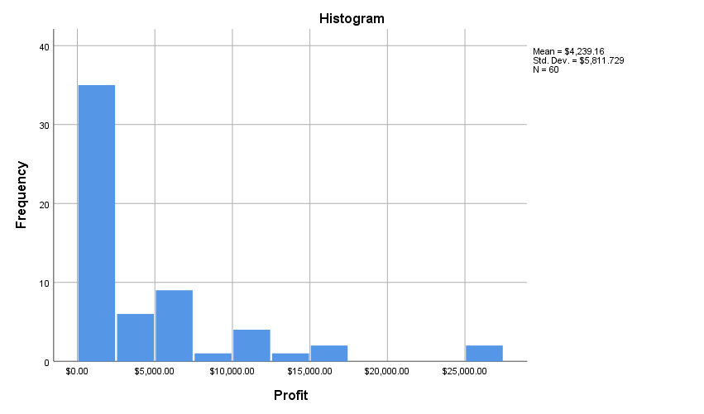

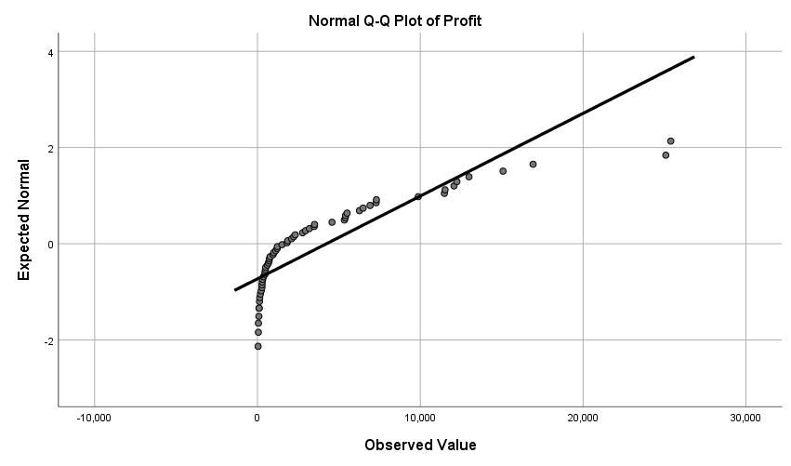

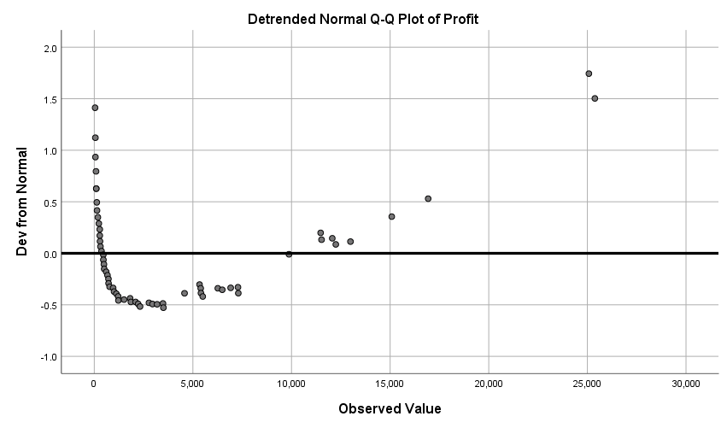

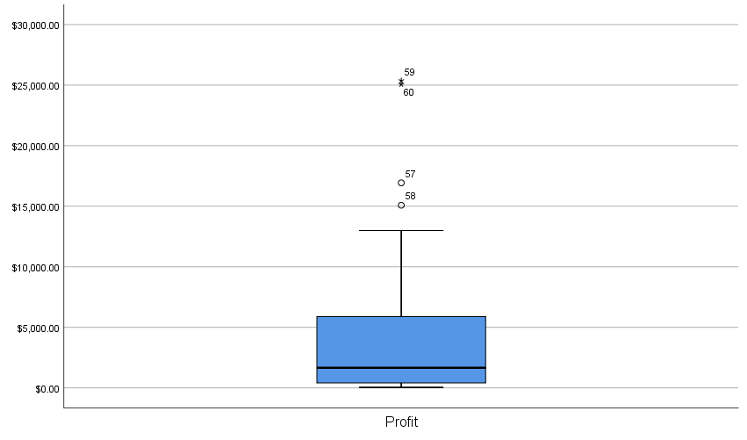

T-TEST
/TESTVAL=0
/MISSING=ANALYSIS
/VARIABLES=Profit
/CRITERIA=CI(.95).

T-Test

Notes
Output Created |  | 04-MAR-2019 11:12:10
Comments
Input | Active Dataset | DataSet1
Input | Filter | <none>
Input | Weight | <none>
Input | Split File | <none>
Input | N of Rows in Working Data File | 60
Missing Value Handling | Definition of Missing | User defined missing values are treated as missing.
Missing Value Handling | Cases Used | Statistics for each analysis are based on the cases with no missing or out-of-range data for any variable in the analysis.
Syntax |  | T-TEST  /TESTVAL=0  /MISSING=ANALYSIS  /VARIABLES=Profit  /CRITERIA=CI(.95).
Resources | Processor Time | 00:00:00.00
Resources | Elapsed Time | 00:00:00.00

One-Sample Statistics
 | N | Mean | Std. Deviation | Std. Error Mean
Profit | 60 | $4,239.1646 | $5,811.72926 | $750.29102

One-Sample Test
 | Test Value = 0
 | t | df | Sig. (2-tailed) | Mean Difference | 95% Confidence Interval of the Difference
 |  |  |  |  | Lower | Upper
Profit | 5.650 | 59 | .000 | $4,239.16458 | $2,737.8357 | $5,740.4934

T-TEST
/TESTVAL=4500
/MISSING=ANALYSIS
/VARIABLES=Profit
/CRITERIA=CI(.95).

T-Test

Notes
Output Created |  | 04-MAR-2019 11:16:36
Comments
Input | Active Dataset | DataSet1
Input | Filter | <none>
Input | Weight | <none>
Input | Split File | <none>
Input | N of Rows in Working Data File | 60
Missing Value Handling | Definition of Missing | User defined missing values are treated as missing.
Missing Value Handling | Cases Used | Statistics for each analysis are based on the cases with no missing or out-of-range data for any variable in the analysis.
Syntax |  | T-TEST  /TESTVAL=4500  /MISSING=ANALYSIS  /VARIABLES=Profit  /CRITERIA=CI(.95).
Resources | Processor Time | 00:00:00.00
Resources | Elapsed Time | 00:00:00.00

One-Sample Statistics
 | N | Mean | Std. Deviation | Std. Error Mean
Profit | 60 | $4,239.1646 | $5,811.72926 | $750.29102

One-Sample Test
 | Test Value = 4500
 | t | df | Sig. (2-tailed) | Mean Difference | 95% Confidence Interval of the Difference
 |  |  |  |  | Lower | Upper
Profit | -.348 | 59 | .729 | -$260.83542 | -$1,762.1643 | $1,240.4934

